Alberta Rowing Association

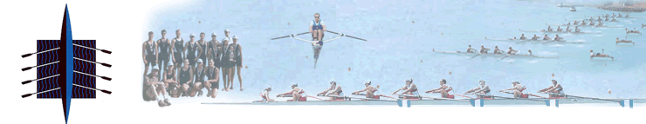

Coaching Conference

The Alberta Rowing Association in association with the Central Alberta Rowing Club is pleased to announce that it will host its sixth annual coaching conference on April 25, 2015 in Lacombe Alberta. For the first time, the focus of this years conference will be on the “Novice Coach; coaches who could use a little hand before hopping into the coach boat for the first time. Material will range from preparing for your first LTR Session, to boat handling to preparing a boat for one’s first row.

The Conference is open to all – athletes, coaches, officials and even parents who wish to not only gain insight into our sport but perhaps even see themselves sitting in the coach boat in the future.
The Conference will take the format as follows: - Location – Lacombe Memorial Centre
Saturday, April 25, 2015
12:30pm - Registration
1:00pm - Welcome and Introductions.
1:15pm – 2:15 Preparing for your First LTR Session - 10 Athletes are down for their first ever LTR Session and every one of them are excited to try our great sport. You on the other hand are trembling. This course will present material on how you can organize matters in preparation for your first LTR session of 2015.
2:15pm – 2:30pm – Coffee Break - All Groups
2:30pm- 3:30pm – Rigging and boat handling for the first row - Introductions are over and everyone is now ready to get on the water. This course will present proper boat handling methods for novice athletes and assist you the coach in getting the foot-stops and rigger in the proper position and the pin at the proper pitch.
3:30pm – 3:45pm Coffee Break - All Groups
3:45pm – 4:45pm – Next Steps – Here coaches will learn drills, games, coaching concepts and safety protocols that they could use help make athletes get the most out of our sport and hopefully register with our prospective clubs.
4:45pm – 5:00pm – Course Wrap Up – Adjourn
5:00pm – 7:00pm – Social at Location TBD

A formal registration form will be distriibuted no later than April 5, 2015.

