Alberta Rowing Association
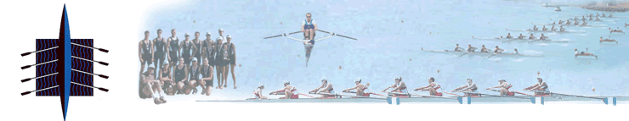

Annual Conference

The Alberta Rowing Association is pleased to announce that it will host its seventh annual conference on February 27th 2016 in Edmonton Alberta. The focus of this conference is to provide a variety of topics that are useful for all individuals involved in the sport of rowing no matter what their role. This conference is open to all coaches, athletes, club administrators, parents and officials. For athletes wishing to attend the conference, the ERC/UART will be hosting an erg session for any and all athletes prior to the conference starting.

The conference will take place at the University of Alberta. A conference schedule and details on how to register are below.
Date: Saturday February 27th, 2016
Time: 9am-4pm
Location: Van Villet Centre, Room 3-205, University of Alberta
9:00am | Registration
9:15am | Welcome and Introduction
9:30-10:30 | Topic: Umpire Experiences  Presenter: Tim Henderson, FISA level umpire  Tim Henderson, a new umpire to Alberta will talk about his experiences as a national and international umpire, why umpire development is important and how umpires can help in setting up a regatta.
10:30-11:15 | Topic: Strategies to Enhance Recovery  Presenter: Roma Oleksyn, Physiotherapist  Athletes often limit optimal performance in training and competition due to a failure to recover adequately. In her presentation, Roma Oleksyn, will explore the reasons why and highlight research that supports strategies to prevent underperformance in athletes.
11:15-11:30 | Break
11:30-12:00 | Topic: Overview of the Rules of Racing and the Umpire-Athlete Relationship  Presenter: Audra Vair (Umpire)  Ever wondered why people throw their hands up at the end of a race? Or what about these “yellow cards” what do they mean and why are they important? All these questions and more will be answered in this session. Umpires have a huge role to play in regattas but not all athletes know what their exact role is. Find out how, as an athlete, you can use an umpire to help you out, and what they can do for you.
12:00-1:00 | LUNCH
1:00-2:00 | Topic: Commonalities of Fast Crews  Presenter: Mark Laidlaw, UofC Head Coach and former national team coxswain  Rowing at an international level takes skill, power, strength and determination. However, when watching an international event, almost all the crews have a different style, yet they all go fast! What is the common thread between these crews that makes them the best in the world? Mark Laidlaw will take us thorough the differences and similarities between some of the best rowers in the world.
2:00-3:00 | Topic: Strength & Conditioning  Presenter: Tessa VanDerVeeken, MSc, CSCS  Senior Sports Conditioning Coach at the Athlete Factory  Tessa explores considerations for optimizing athlete training principles, focusing on the benefits of strength and conditioning in rowing performance. We will look at the importance of periodization for senior and junior athlete development to ensure optimal performance in competition. Are we truly maximizing effectiveness of our athletes' time spent in the weight room? How can we adapt our programming to ensure greatest results throughout our competitive season?
3:00-3:10 | BREAK
3:10-3:30 | Topic: RCA’s New Coaching Pathway  Rowing Canada has recently made changes to coaching development and certification within Canada. We will briefly go over the new pathway to become a certified coach and what you might need to know.
3:30-3:45 | Wrap Up and Adjourn

Registration

The cost to attend the conference is $10.00 and can be paid in person on February 27th.

To register please send an email to the ARA Office at office@albertarowing.ca NO LATER THAN February 24th with the following information:

Name: __________________________________
Club: _________________________________
NCCP number (if applicable):________________________________
If an out of town athlete (i.e. not from Edmonton) will you be attending the erg session prior to the conference? Please indicate YES or NO. ___________________

